COSTA RICA & PANAMA CANAL 2027
FEBRUARY 02-FEBRUARY 09
WINDSTAR LEGEND

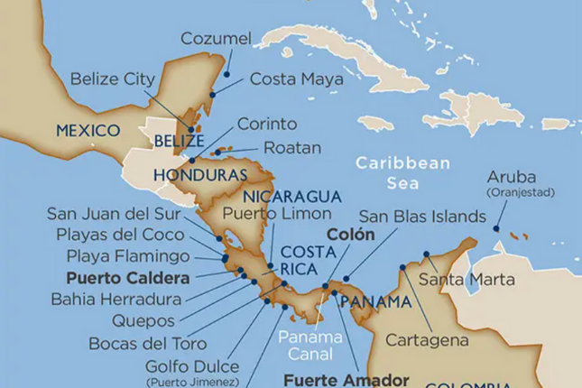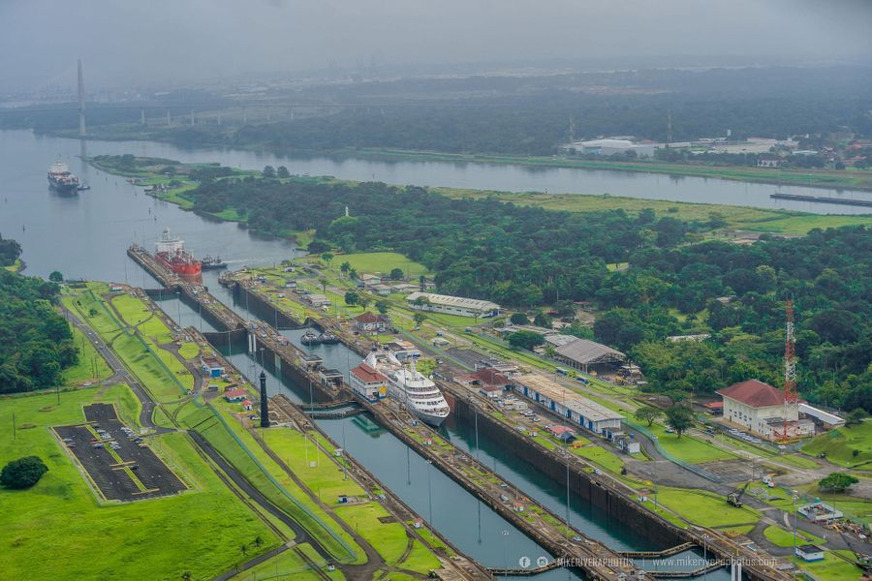

Natural and man-made wonders combine in this exotic region where you are an explorer by day with cocktails on the fantail of your boutique ship by night. Costa Rica is one of the most ecologically diverse places on earth over landscapes of rainforest, lakes, cloud forests, volcanoes, and more, boasting an impressive variety of wildlife. Learn more about their history, flora and fauna from a local Naturalist on board, and transit the massive Panama Canal during daylight hours. Against all this color and adventure, your white star-class ship rests at anchor awaiting your return from a delightful day of exploring.
Limited space from $3206 per person (port hole)
French Balcony Suites $4726 per person (window)

CALL NOW TO RESERVE YOUR CABIN


